Tacological: Creating an impact with tacos and VR

Cole Dennis, Madeline Golliver, Dipti Gupte, Andrea Horvath
Santa Clara University Imaginarium

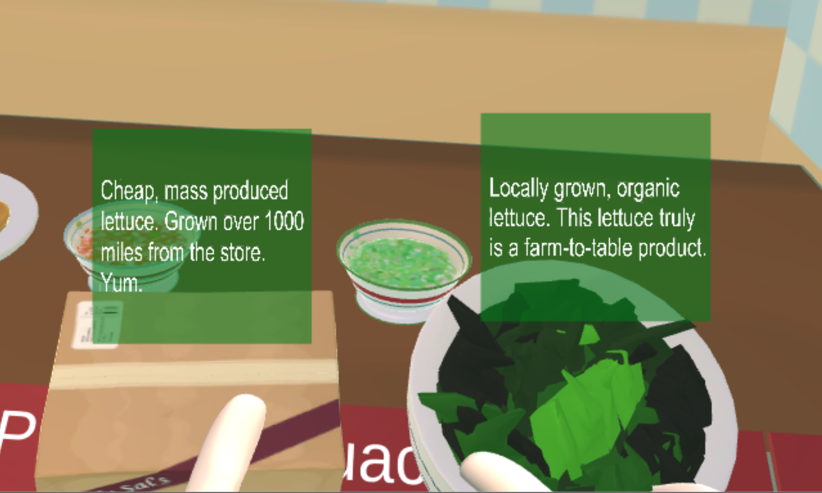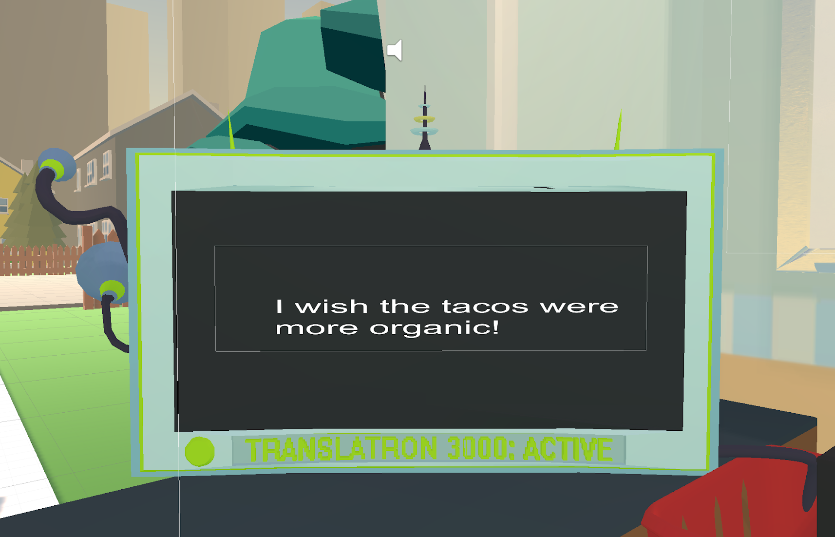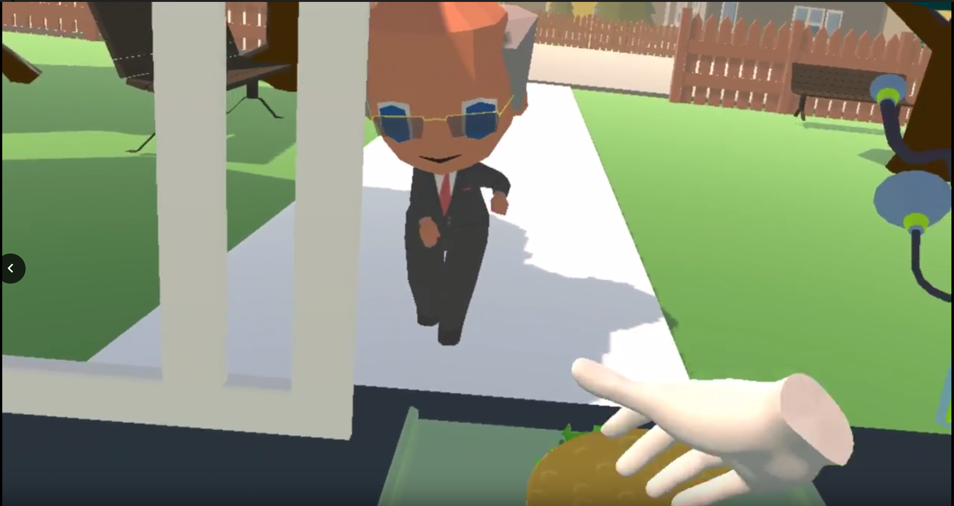
(a) (b) (c)

Figure 1: (a) Shows sustainability facts that appear upon interacting with each ingredient. (b) The translator, through which customers communicate their satisfaction or dissatisfaction with the product based on the ingredients chosen. This message is from a dissatisfied customer. (c) Satisfied customers dance upon receiving their taco, in addition to the appearance of a message on the translator.

1 Introduction

Sustainable food options have become increasingly popular in recent years as awareness of global warming and the negative environmental impact of some food production practices grows. As more food options have become available, people must decide which practices to support when grocery shopping or choosing a restaurant. Games are an effective medium for this type of education.

In 2015, over 70% of Millennials and Gen Z’ers said they are willing to pay more for sustainable products (McCaskill 2015). According to a study done by Forbes, almost 90% of respondents were more likely to positively view, be more loyal towards, and trust a company that was more environmentally friendly. The study also found that respondents were more likely to buy a product that helped the environment (Butler 2018). Seeking out these alternate choices in food, restaurant owners will also be able to help reduce air pollution and energy consumption.

Tacological is a virtual reality game designed to encourage sustainable purchasing practices and teach about the costs that businesses face in providing sustainable products. The player has the option to choose between ingredients that are sourced cheaply or sustainably, and have different associated costs and customer preferences. By highlighting the differences between sustainable and unsustainable food options, players learn about food production, and the effects of food production has on the environment. Players learn to manage their finances, customer satisfaction, and sustainability in order to run a successful business. More importantly, players learn to value the sustainability efforts of restaurants and understand increases to pricing as a result of these efforts.

Virtual reality is an untapped medium for educating consumers on their purchasing decisions. As virtual reality is an effective method of education (Markowitz et al., 2018), our food truck simulator uses this medium to educate players on sustainable food sources and businesses.

2 Our Approach

Our VR environment simulates a food service environment to connect players to the real-world social, monetary, and environmental impacts of businesses.

Players are placed inside a taco truck, where they decide what kind of taco they want to serve customers. The player’s score is broken down into money, popularity points, and sustainability points. These scores, combined with physical and verbal customer reactions as shown in Figure 1(b) and Figure 1(c), inform the player of their success.

A study found that through the use of immersive VR, people experienced deeper learning about complex social and environmental issues (Markowitz et al., 2018). Based on this information, we thought it was important that the player interact with each customer so that players would feel like they are interacting with real people within the game. We rely on this phenomenon at the end of each round, as a city inspector expresses disappointment or excitement over how sustainable the player has been that round, as measured by the ingredients chosen.

We recognized that players needed to be informed to make meaningful decisions in Tacological. Players interacting with an ingredient see a pop-up giving details about that ingredient to educate them of farming practices, as shown in Figure 1(a).

To measure the impact of our game, a survey was taken before and after gameplay. An administrator also took notes on the player’s actions during the experience.

3 Results

Through Tacological, we hoped to impact player purchasing opinions and decisions regarding sustainable food options. We utilized Top Two Box analysis on our Likert scale survey questions to determine the effectiveness of our gameplay. The percent of players who valued food’s environmental impact as extremely or very important rose after playing Tacological from 18.14% to 59.09%. Additionally, the percent of players extremely or very willing to pay more for environmentally friendly food products increased from 13.64% to 27.27%. This is further supported by findings that their price sensitivity of food products decreased from 86.36% to 59.09%, suggesting that players may now be more willing to spend more money on sustainable goods than before the experience. Together, these results suggest that Tacological has the ability to impact food purchasing decisions of players and educate about environmental issues through the gameplay.

References

Butler, A. (2018, November 21). Do Customers Really Care About Your Environmental Impact? Retrieved from Forbes website: https://www.forbes.com/sites/forbesnycouncil/2018/11/21/do-customers-really-care-about-your-environmental-impact/#73b7146c240d

Markowitz, D. M., Laha, R., Perone, B. P., Pea, R. D., Bailenson, J. M. (2018, November 30). Immersive Virtual Reality Field Trips Facilitate Learning About Climate Change. Frontiers in Psychology, 17.

McCaskill, A. (2015, October 12). Consumer- goods brands that demonstrate commitment to sustainability outperform those that don't. Retrieved from Nielsen website: https://www.nielsen.com/us/en/press-room/2015/consumer-goods-brands-that-demonstrate-commitment-to-sustainability-outperform.html

